Capstone Plan Document

Investigating the Shooting-Free Weekend in New York City

Rachel Weber, MPH student

# Background

New York City has a tumultuous history of gun violence. After a significant drop in gun violence in the 1990’s, New York City has made steady progress in reducing shooting incidences in the new millennium. The New York Times reported in August 2019 that gun violence is at a two-decade low for the city3. Many researchers cite the state’s strong gun control laws and progressive police training as the reason for New York’s improvement1. Along with state-level regulation, the national culture around gun ownership and resulting violence has been in major flux. Though New York City’s worst years of gun violence are in the past, growing national incidence of mass shootings has brought community activists to action.

Following the Sandy-Hook shooting in December 2012 and the December 24th Webster shooting, New York passed the Secure Ammunition and Firearms Enforcement Act (SAFE Act) which contains several firearms regulations. These include broader definitions of ‘assault style weapons’, prohibitions on high capacity magazines, mandated background checks, and safe storage provisions. In 2010, New York City implemented Chicago’s Cure Violence public health model to use community outreach as a means of curbing gun violence. As of 2017 there were 18 active Cure Violence programs around the city working to ‘denormalize’ gun violence1.

The first shooting free weekend (Friday, Saturday, Sunday) NYC has had in decades happened in Mid-October 2018. This event made national news with the usual exclamations of ‘amazing’ and ‘a milestone’2. But the crux of the matter is this: what this event a very lucky run or inevitable?

The Law of Truly Large Numbers states that with enough repetitions of an experiment, even outlandishly unlikely events become inevitable. It is logical to consider an event that occurs 1 in 1 million times to be extremely rare, but with a population of roughly 329 million people, the United States is expected to see that event happen to 329 people—not a bad sample size. The same concept allows us to view the shooting-free weekend in NYC through a different lens. With enough weekends and enough time, was a shooting-free weekend bound to happen eventually? Though we have just a few hundred weekends in our dataset, we can still apply probability theory to determine odds.

# Data Description

Data are supplied by NYC Open Data. The dataset spans years 2006 to 2018. Each row contains the time and date of a shooting, the location (precinct and latitude/longitude), and perpetrator/victim demographic information (including sex, race, and age group).

Data is manually extracted every quarter and reviewed by the Office of Management Analysis and Planning. Data is intended for public use to, “explore the nature of shooting/criminal activity” in NYC.

# Study Aims:

This study primarily seeks to ascertain if the shooting-free weekend in NYC in October 2018 was an anomaly or if it was expected to happen. The secondary goal of this study is to build a negative binomial model to predict the number of shootings expected on a given day.

The results of our study will shed light on the likelihood of the shooting-free weekend that happened in October 2018 and provide a model for estimating the number of shootings to occur on a day. This model can be used to understand seasonal and yearly differences in shootings that may impact NYPD and community group policy on reducing risk of gun violence.

# Statistical Hypotheses:

### Primary

|  |  |
| --- | --- |
| Hypothesis | The shooting-free weekend was not an anomaly but was expected |
| Outcome(s) | Probability of a shooting-free weekend |
| Explanatory Variable |  |
| Confounding/Precision Variables |  |
| Analysis Method | Probability Theory |
| Model building approach if applicable |  |
| How will you check and summarize missing data | No missing data |

### Secondary:

|  |  |
| --- | --- |
| Hypothesis | Day of the week is a significant predictor of the number of shootings estimated to occur |
| Outcome(s) | Number of shootings in a day |
| Explanatory Variable | Day of the week |
| Confounding/Precision Variables | Year, season, before/after legislation change |
| Analysis Method | Negative binomial regression |
| Model building approach if applicable |  |
| How will you check and summarize missing data | No missing data |

# Data Analysis Plan

All analyses will be performed in R version XX.XX. I will only be using the date and time data of which there is zero missingness.

Before analyses can begin, the data must be prepared to answer my specific questions. All data points have been verified by New York City before publishing so data quality need not be addressed here. Days without shootings are missing from the dataset so these days will be added as new, empty rows to allow for counts and visualizations of these days. Additionally, a variable for season and year will be added using the time and date variable provided by the city. Finally, a binary variable for pre/post SAFE Act implementation will be added for modeling done to address the secondary hypothesis.

To address the primary hypothesis, I will use manual probability calculations to determine the odds of a consecutive Friday, Saturday, and Sunday having zero shootings, given the data. I will use conditional probability calculations to calculate the probabilities for Saturday and Sunday because I cannot assume that a shooting on Saturday is totally independent of a shooting on Friday, and likewise for Sunday with Saturday and Friday. The final product of this analysis will be a single probability to be interpreted.

To address the secondary hypothesis, I will perform negative binomial regression to predict the number of shootings to occur on a given day. I will start with a simple model that uses a categorical variable for day as the independent variable. I will then check collinearity of Year, Season, and pre/post SAFE Act to affirm that I am not using variables that contribute highly similar information to the model. These will then be added to the model and I will interpret the findings.

# Tables and Figures

### Descriptive:

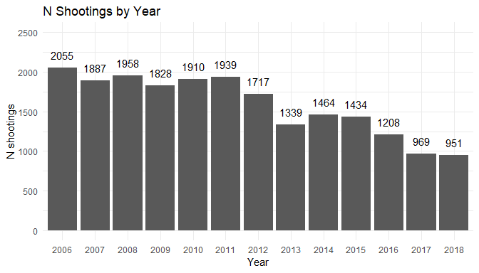

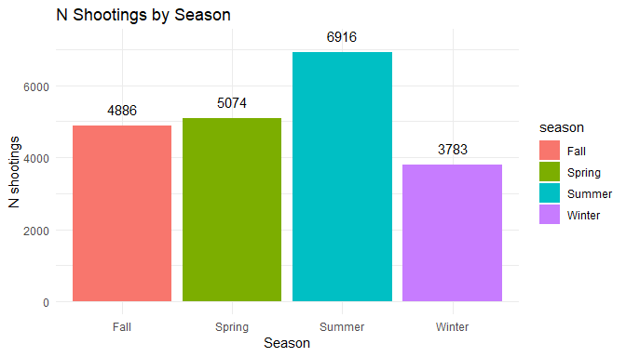

### Aim 1:

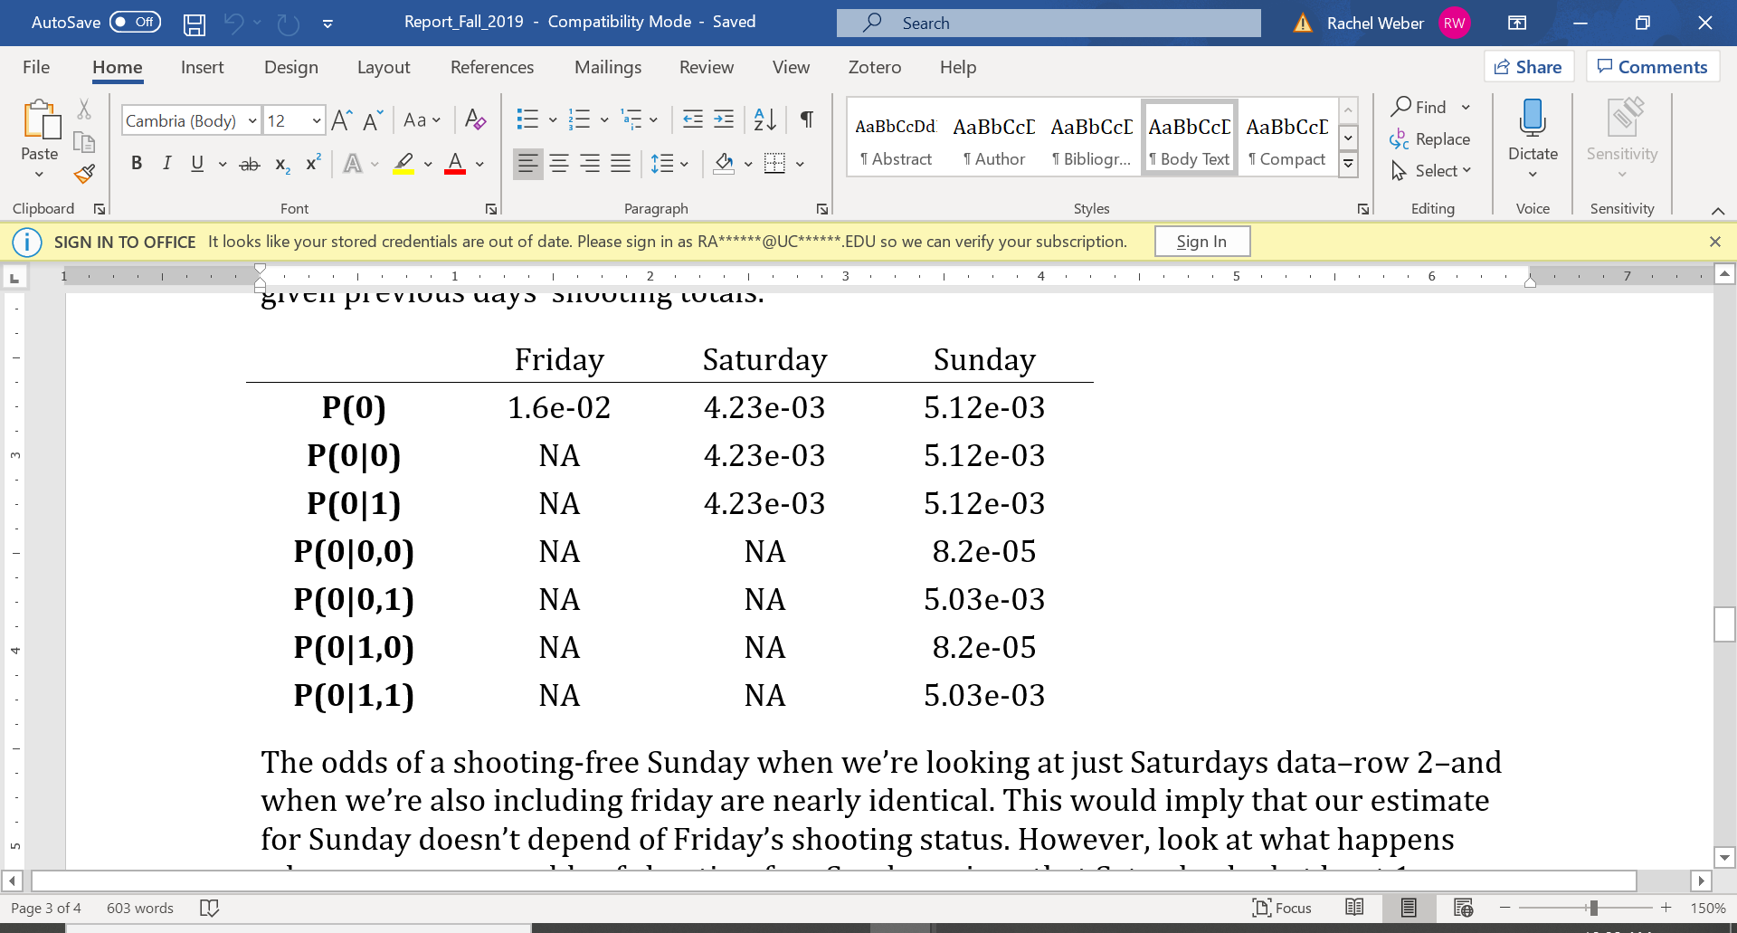

### Aim 2:

|  |  |  |  |
| --- | --- | --- | --- |
| Variable | Estimate | SE | P-value |
| Year |  |  |  |
| Monday |  |  |  |
| Tuesday |  |  |  |
| … |  |  |  |
| Sunday |  |  |  |
| Pre/Post SAFE Act |  |  |  |
| Season |  |  |  |
| Year (or time equivalent yet to be decided) |  |  |  |

References:

1. Delgado, S. A., Alsabahi, L., Wolff, K., Alexander, N., Cobar, P., & Butts, J. A. (2019, July 10). The Effects of Cure Violence Programs in 2 New York City Neighborhoods. Retrieved from https://johnjayrec.nyc/2017/10/02/cvinsobronxeastny/.
2. Lam, K. (2018, October 16). New York City's weekend free of shootings is first in decades. Retrieved from https://www.foxnews.com/us/new-york-citys-weekend-free-of-shootings-is-first-in-decades.
3. Paybarah, A. (2019, August 6). Gun Violence: New York's Own Problem. Retrieved from https://www.nytimes.com/2019/08/06/nyregion/newyorktoday/nyc-gun-violence.html.
4. States with Weak Gun Laws and Higher Gun Ownership Lead Nation in Gun Deaths, New Data for 2015 Confirms. (2017, January 10). Retrieved from http://vpc.org/press/states-with-weak-gun-laws-and-higher-gun-ownership-lead-nation-in-gun-deaths-new-data-for-2015-confirms/.